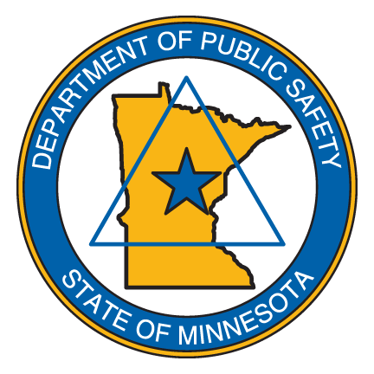

*We will be located on TSQ Main Level between State Patrol and DVS Employee Doors.*

**Friday, February 7th 11am - 1pm**

***How can we make our workplace better?***

***Tell us the good, bad and the ugly!***

***Our union is here to help everyone have a better work life.***

***Together, as one team, we have a stronger voice to be heard!***

***Snacks and refreshments will be served!***

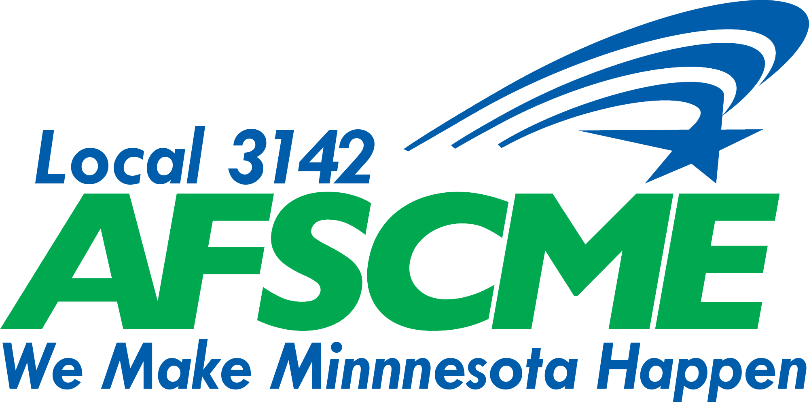

# WE WANT TO HEAR FROM YOU!